Vision Document  
[SmartHome+ : A Smart Home Platform]

# Introduction

The purpose of this document is to outline a vision for SmartHome+ : A smart home platform. The document addresses the following:

* Identify and agree on the need for end users and determine features for the smart home platform.
* Gather and describe user requests for smart-home software platform features
* Propose new and alternative solutions
* Identify limitation and assumption for proposed solution
* Identify stakeholders and users
* Identify user environment

The scope of this document is limited to user needs, environment, and desired solution.

# Positioning

## Problem Statement

|  |  |
| --- | --- |
| The problem of | * Disconnected devices and appliances * Unmonitored home environment (temperature, air, and water quality) * Energy waste * Home security * Decentralized media and entertainment devices * Repetitive daily task |
| Affects | The home residents:   * Adults * Children * Senior members * Pets |
| The impact of which is | Making it difficult for homeowners to manage, synchronize and monitor different daily activity. |
| A successful solution would be | Summation and harmonization of the following service through a centralized smart home platform:   * Accessibility (ease of use) * Environment Monitoring * Energy efficiency control * Enhanced security * Media and entertainment * Automation of various tasks |

## Product Position Statement

|  |  |
| --- | --- |
| For | Homeresidents |
| Who | Are finding hard to manage, monitor and synchronize variety of devices and automating daily tasks |
| The [SmartHome+] | is a Smart Home platform |
| That | Enables users to:   * Manage and sync their devices and appliances * Monitor home environment * Increase energy efficiency and save costs * Have security from intrusion and accidents * Sync and control various media and entertainment platform and devices * Automate daily tasks |
| Unlike | Other products in market that only provide a subset of features users need |
| Our product | Fulfills users need by integrating all the desirable features for a smart-home in a single platform. |

## Stakeholder Summary

|  |  |  |
| --- | --- | --- |
| Name | Description | Responsibilities |
| Smart Solutions inc | The owner of the project | * Provide a high level product description * Monitors and manages the project * Finalizes different proposal * Approves budget * Provides feedback * Participate in User Acceptance Testing. |
| Users | Homeowners who will be using the solution | * Provide feedback and comments. * Suggest new features and modifications |
| Developers | The team responsible for eliciting requirements and developing the product. | * Requirement elicitation and analysis to come up with a Software Requirement Specification (SRS) document. * Designing, Developing and Testing the system. * Preparing documentation and user guides. * Post delivery maintenance of the system. |

## User Environment

User can access the system both locally and remotely. Local access includes local monitors and voice-based assistants. Remote access can be achieved using Mobile/Browser app. The system is self-evolving based on the user’s daily routines; however, user also can override the system. User’s will receive notifications through email and/or SMS concerning the status of the system. System will trigger alarms and send notifications when safety is compromised (Ex: Fire, flood, intrusion).

# Product Overview

## Product Perspective

[This subsection of the **Vision** document puts the product in perspective to other related products and the user’s environment. If the product is independent and totally self-contained, state it here. If the product is a component of a larger system, then this subsection needs to relate how these systems interact and needs to identify the relevant interfaces between the systems. One easy way to display the major components of the larger system, interconnections, and external interfaces is with a block diagram.]

The Smarthome+ is a home automation solution which integrates various IoTs in a household through a controller to automate daily home tasks, enhance accessibility to the IoTs , provide home security and reduce energy waste.

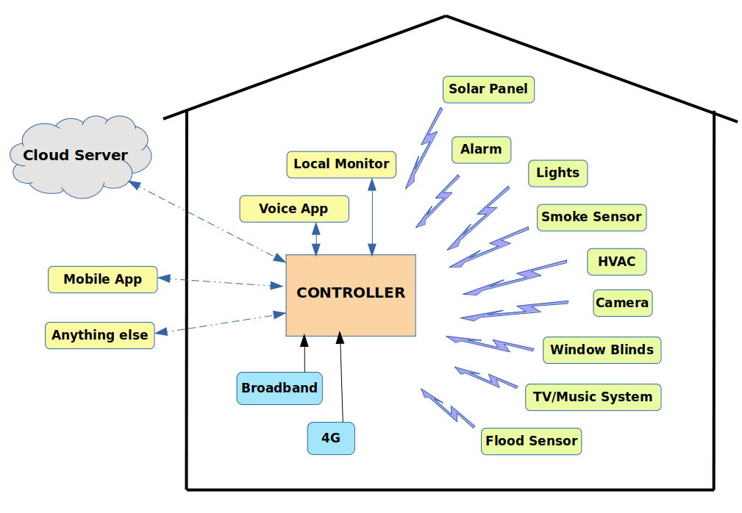

## Assumptions and Dependencies

[List each factor that affects the features stated in the **Vision** document. List assumptions that, if changed, will alter the **Vision** document.

For example, an assumption may state that a specific operating system will be available for the hardware designated for the software product. If the operating system is not available, the **Vision** document will need to change.]

|  |  |
| --- | --- |
| Assumptions | Dependencies |
| Controller and the devices are compatible with each other. | Communication between the devices and controller happens via WiFi/Bluetooth |
| Internet connectivity is available for remote access. | Mobile/browser apps use the Internet to communicate with the controller. |
| APIs to control the IoTs are available | Controller monitor and control the devices using APIs |
| Environment is free from poor wifi signal, interference and signal jamming from external devices. | Controller and devices communicate via WiFi/Bluetooth |

## Needs and Features

*[Avoid design. Keep feature descriptions at a general level. Focus on capabilities needed and why (not how) they should be implemented.]*

|  |  |  |  |
| --- | --- | --- | --- |
| Need | Priority | Features | Planned Release |
| *[State a need]* | *[Set priority:*  *High, Normal, Low]* | *[Name the feature]* |  |

## Alternatives and Competition

[Identify alternatives the stakeholder perceives as available. These can include buying a competitor’s product, building a homegrown solution, or simply maintaining the status quo. List any known competitive choices that exist or may become available. Include the major strengths and weaknesses of each competitor as perceived by the stakeholder or end user.]

# Other Product Requirements

[At a high level, list applicable standards, hardware, or platform requirements; performance requirements; and environmental requirements.

Define the quality ranges for performance, robustness, fault tolerance, usability, and similar characteristics that are not captured in the Feature Set.

Note any design constraints, external constraints, or other dependencies.

Define any specific documentation requirements, including user manuals, online help, installation, labeling, and packaging requirements.

Define the priority of these other product requirements. Include, if useful, attributes such as stability, benefit, effort, and risk.]

5.1 Hardware requirements:

* The controller and the devices have the required hardware to enable communication using WiFi/Bluetooth.
* Controller has provision for SIM to enable 4G and WAN ports for Broadband connectivity.
* Controller is equipped with RAM and SDcard to store local information.
* Controller can connect and run on battery backup.
* Rechargeable batteries supported by the controller.

5.2 Platform requirements:

* Controller runs on LINUX and supports the JAVA environment. The firmware will be implemented in Java.
* Firmware/Software upgrades will happen over Broadband (primary) or 4G (secondary).

5.3 Performance requirements:

* 24 hours battery backup in case of power failure.
* Access to 4G during broadband failure.
* Expected latency to send and receive commands to the devices is < 1 second.
* Expected latency to receiving notifications is 1-2 seconds.
* Ability to detect malfunctioning devices and power loss.
* Expected latency between cloud server and controller is < 1 second.

5.4 Security

All transmissions to and from the controller are encrypted to ensure privacy and data integrity. Authentication modes to the system include password, voice and face recognition and only authorized users can monitor and control the system.

5.5 Standards:

Devices and controller are compliant with CE (European Conformity) and FCC (Federal Communications Commission) standards and other required local regulatory services. Additionally the product will be UL certified.

5.6 Documentation:

User manual and installation documentation are produced which instructs on recommended and safe installation and usage of the system.

5.7 Risk:

* The system will not function when there is a power failure and when the battery runs out.
* The system will not be remotely accessible in case of broadband failure and poor 4G connectivity.

Glossary:

* Controller -
* Devices -
* IoT -
* Firmware

References:

<https://www.iotas.co.uk/ce-fcc-regulatory-services/>